Southwest Alberta Rural Crime Watch Association
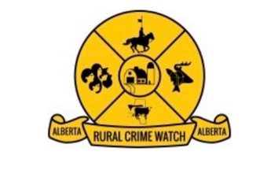
Application for Membership

Name: ___________________________________________
Mailing Address: __________________________________
Postal Code: ______________
Legal Land Location: ______________________________
Civic Address (blue sign): __________________________
Home Phone: _____________________________________
Cell Phone: _______________________________________
E-mail Address: ___________________________________

I, the undersigned, agree that if my participation with Southwest Alberta Rural Crime Watch Association is found to be unsatisfactory by the Association’s Executive and/or the Pincher Creek or Crowsnest Pass RCMP, for any reason, my membership will be terminated and the material supplied to me by the Association, including my membership sign will be surrendered. I understand that in order to maintain the integrity of the program, Rural Crime Watch signs are for members of the Association only. I agree to remove all Crime Watch signs from my property and notify the Association when I am no longer the owner of the above-mentioned property.

_________________________________ ___________________
Applicant Signature Date

Membership payment of $25.00 can be made by cash, cheque or e-transfer. E-transfer to swarcw@gmail.com. Cheques payable to Southwest Alberta Rural Crime Watch Association and mailed to:
Southwest Alberta Rural Crime Watch
PO Box 279
Pincher Creek, AB, T0K 1W0

Working together with the Pincher Creek and Crowsnest Pass RCMP, Fish & Wildlife, and the MD of Pincher Creek Enforcement Services.

